10-2 20181102
EN | Thai
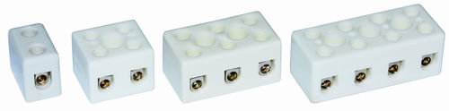
Type BA: Steatite connection blocks, 250V range
With pressure screws, protected against electric shock
Features:These high-quality and small foot-print terminal blocks allow efficient and easy wiring of halogen lamps, heating elements, infrared heaters and quartz tube heaters. Maximum operating voltage is 250V, for 1.5~4mm² conductor, Maximum ambient temperature: Permanent is 230°C, Peak is 450°C.

